eMart Design

|  |  |  |
| --- | --- | --- |
| File status：  [√] daft  [] Deploy  [ ] Update | File ： | Design |
| Version： | 0.1 |
| Complete  Date： | 2020/4 |

Version History

|  |  |  |  |
| --- | --- | --- | --- |
| Version/Status | Participant | Start Date | Remarks |
| 0.1 daft |  | 2020/04 | Git: https://github.com/CarlCool/eMartCase |

Contents

1. Business Requirement 3

1.1. Roules 3

2. Function 4

2.1. Signup 4

2.2. Login/Logout 4

2.3. Search Item by Buyer 4

2.4. Cart Management (Buyer) 4

2.5. Commodity Management(seller) 5

*3.* *Table design* 6

3.1. User informatin 6

3.2. *Item* information 6

*4.* *WireFrame* 9

# Business Requirement

eMart is an online eCommerce portal used to search and buy an item online. Buyer can add items to the cart, checkout and perform other operations. Admin can block/unblock Seller, Buyer, selling items. Below are eMart Features in detail.

## Roules

#1. Buyer : User who can buy item in eMart system

#2. Seller : User who can sell item in eMart system

# Function

## Signup

Describtion : Buyer or seller can signup in eMart system

Flow:

1. User select the roles to signup (buyer or seller).
2. User input signup information

Buyer: username, password, emailId, mobilenumber

Seller: username, password, company/individual name, Postal Adress, GSTIN, Bank detail, connect number

1. Check if the same user existed in system.
2. If User not exist in system signup successful
3. If User not exist in system signup with error

## Login/Logout

Describtion : Buyer or seller can Login/Logout in eMart system

Flow:

1. User select the roles to login(buyer or seller)
2. User in put emailaddress and password to login
3. Check if the the password is correct
4. If login successful display the home page of eMart system
5. If login fail display the fail message.
6. User can click the Logout button in eMart system to Logout.

## Search Item by Buyer

Describtion : User can search item in eMart system

Flow:

1. Buyer input the item name in search component
2. Search product DB to get item
3. If item exist reploy buyer the list of items
4. If item not exist reploy buyer there is no items.
5. When buyer select item in items list, details of item displayed
6. Buyer can add item to cart by click add to cart button

## Cart Management (Buyer)

Describtion: User can checkout and delete items in cart.

Flow:

1. User click the cart button to the cart page
2. User can delete item in cart by click delete button on each item
3. User can go to check out page by click check out button on each item.
4. When user click check out button the details of item display and user need to add address and connect informations to receive items and user can also to apply discount before check out
5. User can view History of purchases, along with Item, numbers

## Commodity Management(seller)

1. Seller can add item to be sold along with the number of items
2. Seller can view the Inventory(items sold and remaining)
3. Seller can generate report like number of items sold and which items, over certain period

# *Table design*

## User informatin

Buyer

|  |  |  |
| --- | --- | --- |
| **Name** | **Field name** | **Describtion** |
| id | Id | Unique id |
| User name | UserName | Nick name |
| Pass word | passWord | password |
| Email id | emailId | email |
| Mobile number | mobileNumber | Phone Number |
| Create date time | createDateTime | Create date and time |

Seller

|  |  |  |
| --- | --- | --- |
| **Name** | **Field name** | **Describtion** |
| Id | Id | Unique id |
| User name | userName | Nick name |
| Pass word | passWord | password |
| Email id | emailId | email |
| Connect number | connectNumber | Phone Number |
| Company name | companyName | Company/individual Name |
| GSTIN | GSTIN | GSTIN |
| Brief about company | companyBrief | Brief of company |
| Postal address | postalAddress | Postal address |
| website | website | Website of items |
| Bank number | bankNumber | The bank number of seller |

## *Item* information

Category

|  |  |  |
| --- | --- | --- |
| **Name** | **Field name** | **Describtion** |
| Category id | categoryId | Unique id |
| Category name | categoryName | Category name |
| Brief detail | briefDetail | Detail of category |

Subcategroy

|  |  |  |
| --- | --- | --- |
| **Name** | **Field name** | **Describtion** |
| Subcategory id | subcategoryId | Unique id |
| Subcategory name | subcategoryName | Subcategory name |
| Category id | categoryId | Category Id |
| Brief detail | briefDetail | Detail of subcategory |
| GST | GST | GST |

Item details

|  |  |  |
| --- | --- | --- |
| **Name** | **Field name** | **Describtion** |
| id | id | Unique id |
| Category id | categoryId | Category id |
| Subcategory id | subcategoryId | Subcategory id |
| price | price | Price of item |
| Item name | itemName | Item name |
| description | description | Description of item |
| Stock number | stockNumber | Stock number of item |
| remarks | remarks | remarks |
| Owner | owner | Seller id |

Purchase History

|  |  |  |
| --- | --- | --- |
| **Name** | **Field name** | **Describtion** |
| id | id | Unique id |
| Buyer id | buyerId | Buyer id |
| Seller id | sellerId | Seller id |
| Transfer id | transferId | Transfer id |
| Item id | itemId | Itme id |
| Item Name | itemName | Name of item |
| Number of items | numberItems | Numbern of items |
| Item Price | itemPrice | Item Price |
| Date time | dateTime | Date time |
| Discount Percentage | discountPercentage | Discount percentage if apply discount |
| Tax | tax | Tax of item |
| remarks | remarks | remarks |

Transactions

|  |  |  |
| --- | --- | --- |
| **Name** | **Field name** | **Describtion** |
| id | id | Unique id |
| Buyer id | buyerId | Buyer id |
| Seller id | sellerId | Seller id |
| Transfer type | trasferId | Tranfer type(Eg. Debit or credit) |
| Date time | dateTime | Date time of transaction happen |
| remarks | remarks | remarks |

Discounts

|  |  |  |
| --- | --- | --- |
| **Name** | **Field name** | **Describtion** |
| id | id | Unique id |
| Discount code | discountCode | Discount code |
| percentage | percentage | Percentage discount of item |
| Start date | startDate | Start date of discount |
| End date | endDate | End date of discount |
| descripiton | description | description |

Cart

|  |  |  |
| --- | --- | --- |
| **Name** | **Field name** | **Describtion** |
| id | id | Unique id |
| Item id | itemId | itemId |
| Item Numbers | itemNumbers | Numbers of item |
| Buyer Id | buyerId | Id of who add to Cart |
| Last update date | updateDate | Date of last update |

# *WireFrame*

Home

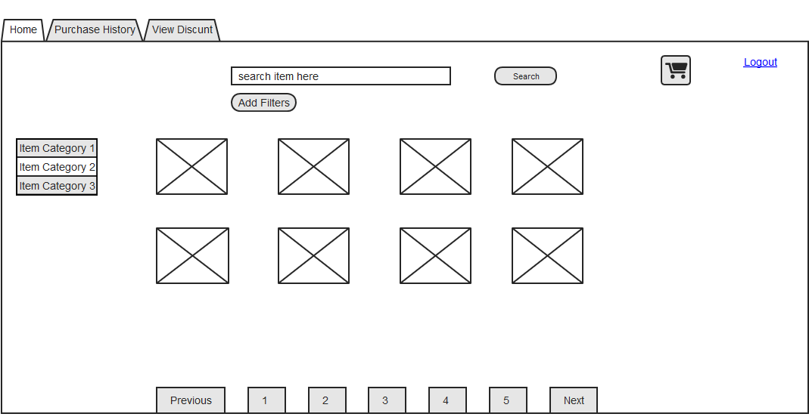

Purchase History

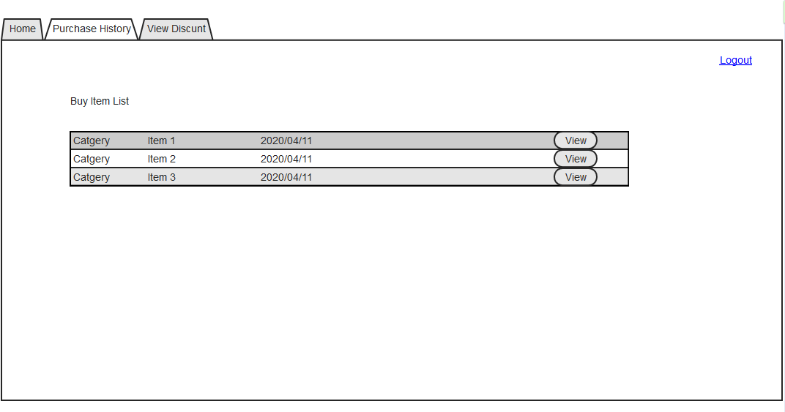

View Discounts

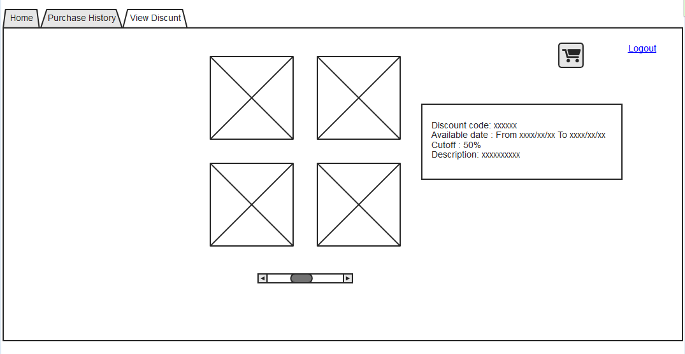

Shoping Cart

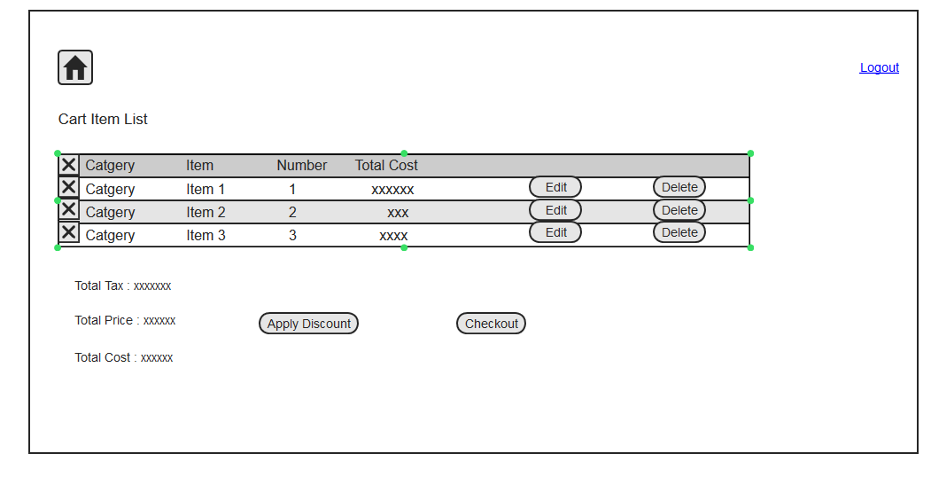

Item Detail

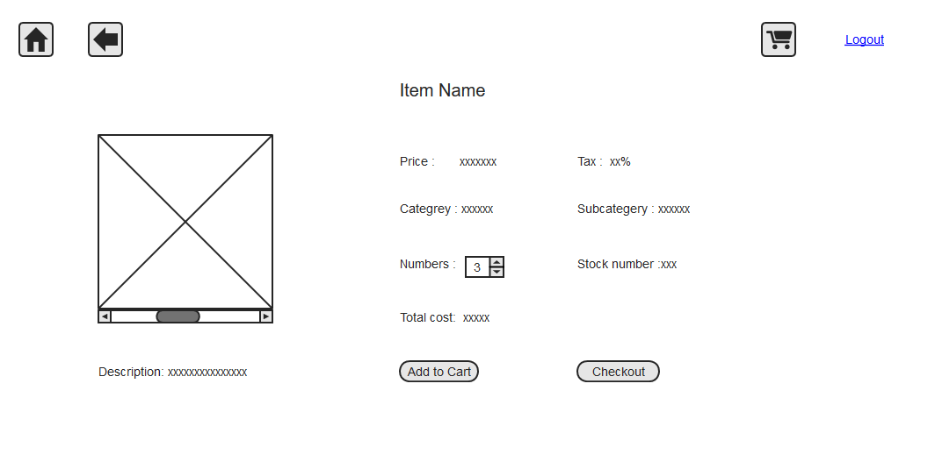

Add Item (Seller)

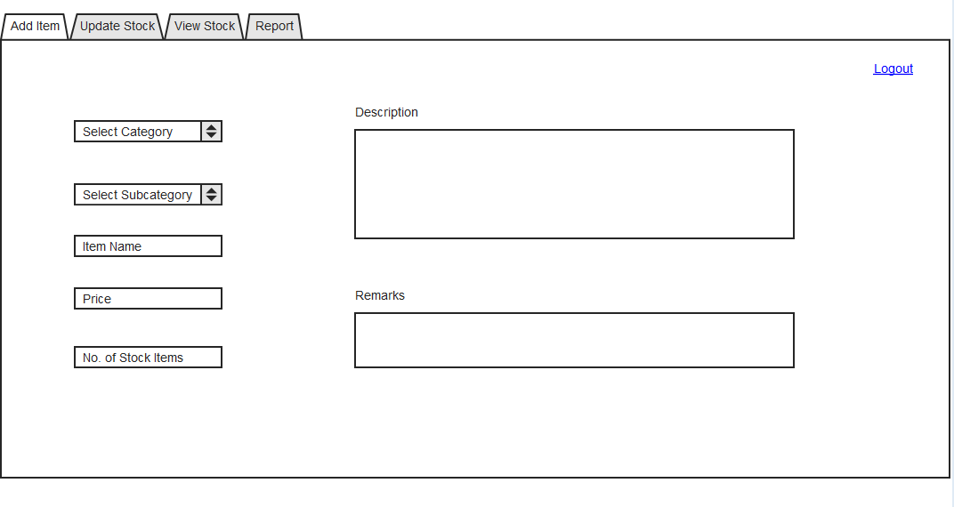

Report (Seller)

